**Practical 1: Use Wireshark tool and explore the packet format and content at each OSI layer**

**What is Wireshark?**

Wireshark is an open-source packet analyzer, which is used for education, analysis and network troubleshooting.

It is used to track the packets so that each one is filtered to meet our specific needs. It is commonly called as a sniffer, network protocol analyzer, and network analyzer. It is also used by network security engineers to examine security problems. Wireshark is a free to use application which is used to apprehend the data back and forth.

## Uses of Wireshark:

1. It is used by network security engineers to examine security problems.
2. It allows the users to watch all the traffic being passed over the network.
3. It is used by network engineers to troubleshoot network issues.
4. It also helps to troubleshoot latency issues and malicious activities on your network.
5. It can also analyze dropped packets.
6. It helps us to know how all the devices like laptop, mobile phones, desktop, switch, routers, etc., communicate in a local network or the rest of the world.

### **What is a packet?**

A packet is a unit of data which is transmitted over a network between the origin and the destination.

## Functionality of Wireshark:

Wireshark is similar to tcpdump in networking. **Tcpdump** is a common packet analyzer which allows the user to display other packets and TCP/IP packets, being transmitted and received over a network attached to the computer. It has a graphic end and some sorting and filtering functions. Wireshark users can see all the traffic passing through the network.

**Background**

## User-added image

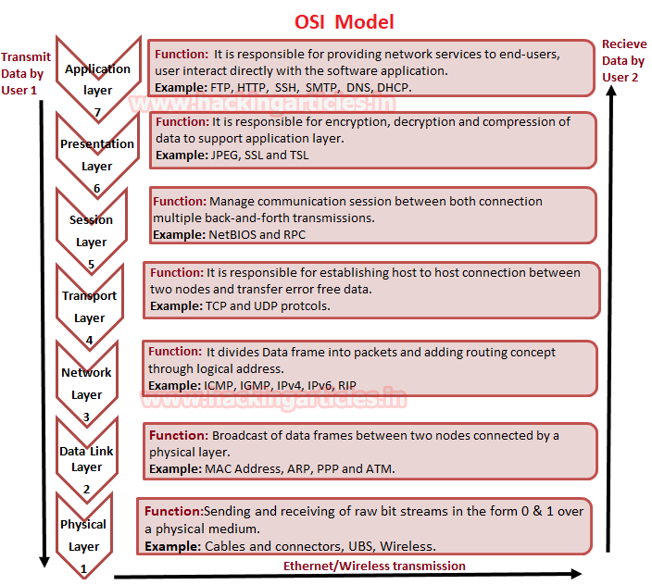

**Use Wireshark tool and explore the packet format and content at each OSI layer**

Basically when a user opens an application for sending or receiving Data then he directly interacts with the application layer for both operations either sending or receiving of data. For example, we act as a client when use Http protocol for uploading or Downloading a Game; FTP for downloading a File; SSH for accessing the shell of the remote system.

While connecting with any application for sharing data between server and client we make use of Wireshark for capturing the flow of network traffic stream to examine the OSI model theory through captured traffic.

From given below image you can observe that Wireshark has captured the traffic of four layers in direction of the source (sender) to destination (receiver) network.

Here it has successfully captured Layer 2 > Layer 3 > Layer 4 and then Layer 7 information.

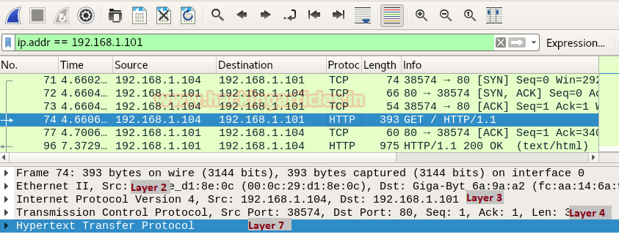

**Ethernet Header (Data Link)**

Data link layer holds 6 bytes of **Mac address** of sender’s system and receiver’s system with 2 bytes of **Ether type** is used to indicate which protocol is encapsulated i.e. IPv4/IPv6 or ARP.

In Wireshark Ethernet II layer represent the information transmitted over the data link layer. From given below image you can observe that highlighted lower part of Wireshark is showing information in Hexadecimal format where the first row holds information of Ethernet headers details.

So here you can get the **source and destination Mac address** which also available in Ethernet Header.

The row is divided into three columns as described below:

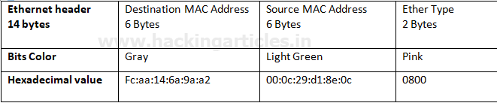

As we know the MAC address of the system is always represented in Hexadecimal format but both types are generally categorized in the ways given below :

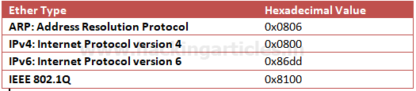

Once again if you notice the given below image then you can observe the highlighted text in Pink colour is showing hex value **08 00** which indicates that here**IPv4** is used.

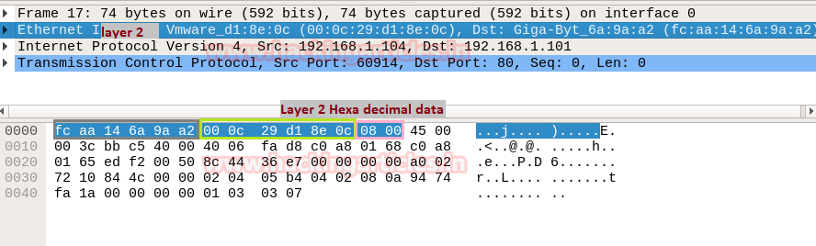

**IP Header (Network Layer)**

IP header in Wireshark has described the network layer information which is also known as the backbone of the OSI model as it holds Internet Protocol version 4’s complete details. **Network layer divides data frame into packets and defines its routing path** through some hardware devices such as routers, bridges, and switches. These packets are identified through their logical address i.e. source or destination network IP address.

In the image of Wireshark, I have highlighted six most important values which contain vital information of a data packet and this information always flows in the same way as they are encapsulated in the same pattern for each IP header.

Now here,**45** represent IPheader length where “4” indicates**IP version 4** and “5” is header length of **5 bits**. while **40** is time to live (**TTL**) of packet and **06**is hex value for **TCP** protocol which means these values changes if anything changes i.e. TTL, Ipv4 and Protocol.

Therefore, you can take help of given below table for examining TTL value for the different operating system.

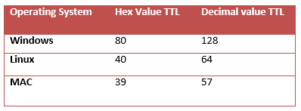

Similarly, you can take help of given below table for examining other Protocol value.

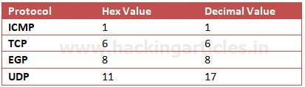

From given below image you can observe Hexadecimal information of the IP header field and using a given table you can study these value to obtain their original value.

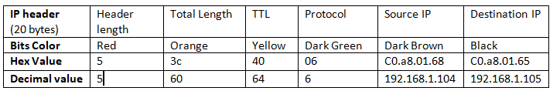

The IP header length is always given in form of the bit and here it is 5 bytes which are also minimum IP header length and to make it 20 bytes, multiply 4 with 5 i.e. 20 bytes.

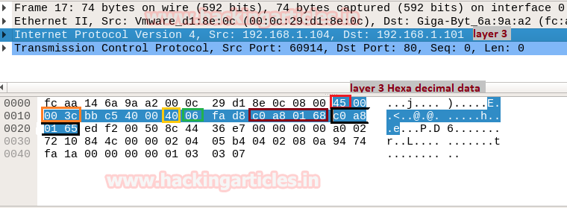

**TCP Header (Transport Layer)**

Transmission Control Protocol (TCP) and User Datagram Protocol (UDP) and Internet Control Message Protocol (ICMP) are the major protocols as it **gives host-to-host connectivity** at the Transport Layer of the OSI model. It is also known as Heart of OSI model as it plays a major role in transmitting errors free data.

By examining  Network Layer information through Wireshark we found that here TCP is used for establishing a connection with destination network.

We knew that a computer communicates with another device like a modem, printer, or network server; it needs to handshake with it to establish a connection.

TCP follows **Three-Way-Handshakes** as describe below:

A client sends a TCP packet to the server with the **SYN flag**

A server responds to the client request with the **SYN** and **ACK** flags set.

Client completes the connection by sending a packet with the **ACK** flag set

Structure of TCP segment

Transmission Control Protocol accepts data from a data stream, splits it into chunks, and adds a TCP header creating a TCP segment. A TCP segment only carries the sequence number of the first byte in the segment.

A TCP segment consists of a segment header and a data section. The TCP header contains mandatory fields and an optional extension field.

|  |  |
| --- | --- |
| **Source Port** | The 16-bit source port number, Identifies the sending port. |
| **Destination Port** | The 16-bit destination port number. Identifies the receiving port |
| **Sequence Number** | The sequence number of the first data byte in this segment. If the SYN control bit is set, the sequence number is the initial sequence number (n) and the first data byte is n+1. |
| **Acknowledgment Number** | If the ACK control bit is set, this field contains the value of the next sequence number that the receiver is expecting to receive. |
| **Data Offset** | The number of 32-bit words in the TCP header. It indicates where the data begins. |
| **Reserved** | Six bits reserved for future use; must be zero. |
| **Flags** | CWR, ECE, URG, ACK, PSH, RST, SYN, FIN |
| **Window** | Used in ACK segments. It specifies the number of data bytes, beginning with the one indicated in the acknowledgment number field that the receiver (the sender of this segment) is willing to accept. |
| **Checksum (**Checksum is a simple error detection mechanism to determine the integrity of the data transmitted over a network.) | The 16-bit one’s complement of the one’s complement sum of all 16-bit words in a pseudo-header, the TCP header, and the TCP data. While computing the checksum, the checksum field itself is considered zero. |
| **Urgent Pointer** | Points to the first data octet following the urgent data.  Only significant when the URG control bit is set. |
| **Options** | Just as in the case of IP datagram options, options can be  either:  – A single byte containing the option number  – A variable length option in the following format |
| **Padding** | The TCP header padding is used to ensure that the TCP header ends and data begins on a 32-bit boundary.  The padding is composed of zeros. |

From given below image you can observe Hexadecimal information of TCP header field and using the given table you can study these value to obtain their original value.

Sequence and acknowledgment numbers are is a major part of TCP, and they act as a way to guarantee that all data is transmitted consistently since all data transferred through a TCP connection must be acknowledged by the receiver in a suitable way. When an acknowledgment is not received, then the sender will again send all data that is unacknowledged.

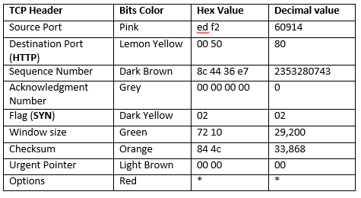

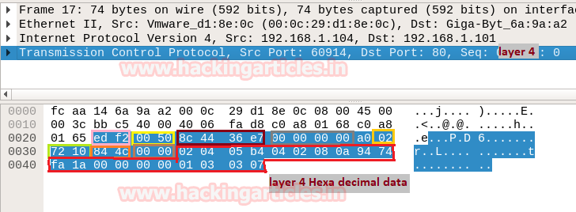

Using given below table you can read Hex value of other Port Number and their Protocol services. Although these services operate after getting acknowledgment from the destination network and explore at application layer OSI model.

In this way, you can examine every layer of Wireshark for Network Packet Forensic.

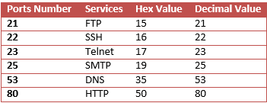

**Using Wireshark to Observe the TCP Three-way Handshake**

* Generate a TCP connection using a web browser
* Observe the initial TCP/IP three-way handshake

In this lab, you use the Wireshark network packet analyzer (also called a packet sniffer) to view the TCP/IP packets generated by the TCP three-way handshake. When an application that uses TCP first starts on a host, the protocol uses the three-way handshake to establish a reliable TCP connection between two hosts. You will observe the initial packets of the TCP flow: the SYN packet, then the SYN ACK packet, and finally the ACK packet.

Step 1: Prepare Wireshark to Capture Packets

Step 2: Filter the capture to view only TCP packets.

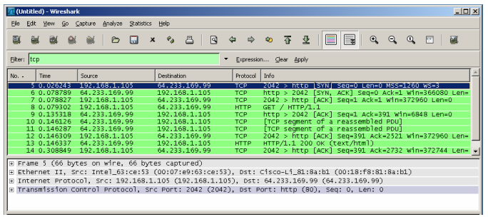

Step 3: Inspect the TCP initialization Sequence

1. In the top Wireshark window, click on the line containing the first packet identified.
2. This highlights the line and displays the decoded information from that packet in the two lower windows fill.
3. Click the + icon to expand the view of the TCP information. To contract the view, click the – icon.
4. Notice in the first TCP packet that the relative sequence number is set to 0, and the SYN bit is set to 1 in the Flags field.

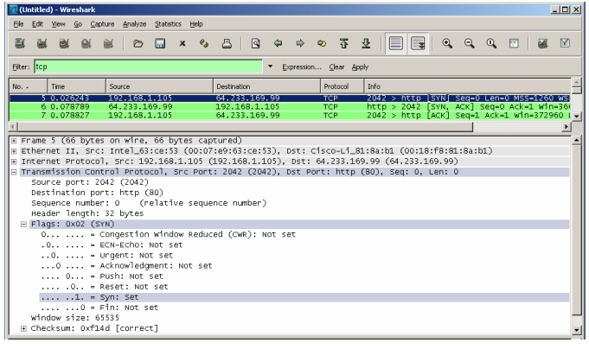

1. Notice in the second TCP packet of the handshake that the relative sequence number is set to 0, and the SYN bit and the ACK bit are set to 1 in the Flags field.

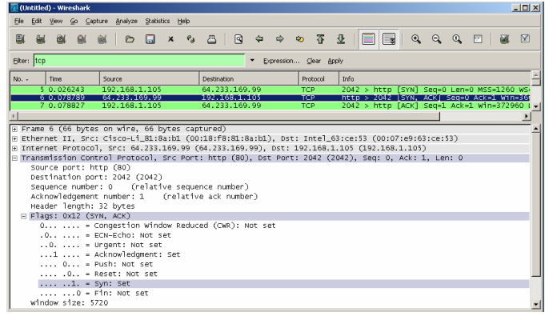

1. In the third and final frame of the handshake, only the ACK bit is set, and the sequence number is set to the starting point of 1. The acknowledgement number is also set to 1 as a starting point. The TCP connection is now established, and communication between the source computer and the web server can begin.

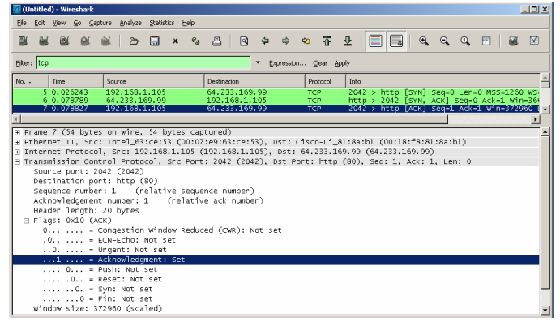

Experiment:

1. Send ping request to any computer and observe the ICMP protocol suing Wireshark.
2. Open any webpage and observe the HTTP protocol using Wireshark.

Video Tutorial: https://www.youtube.com/watch?v=jvuiI1Leg6w